

Customer Personality Analysis

Prepared By:

Yasser Al-batyeh Data Science trainee

September 10, 2021

Prepared for:

The National ICT Up skilling Program –

Al-Hussain Technical University

Table of Contents

Summary 3

Introduction 4

Methodology 5

Result 6

Discussion 6

Conclusions 6

References 7

Table of Figures

Figure 1: total amount spent 5

Figure 2: amount spent 6

Figure 3: dataset 6

# Summary

This project addresses the problem of Customer Personality Analysis [1]. The aim of this project is to predict the amount spent on product using Python. customer behavior and personality can predict many different products that may he/she will like it, but in this report, we have few customers behaviors and personalities. The training dataset is small (just over 2240 examples) and the data within it is highly skewed, which greatly impacts over the difficulty of building a good regressor. After creating a lot of customer features, behavior representations and applying the gradient boosting regression algorithm, the regression accuracy at the level of 88% is achieved.

# Introduction

This dataset is collected in April 2019 by a company. A company collects this dataset to provide customers product consumption for the research which the company does to investigate deep learning approaches for customer behavior.

The ability to understand the customer behavior is increasingly considered as an important tool for market understanding and customer segmentation.

So, from this project, I receive an opportunity to work in customer personality analysis field. Also, it will be beneficial for my startup. Because dealing with the behaviors and personalities of customers, we want to interpret what user tends to like so that we can give him best recommended results.

Apart from this personal and behavioral analysis, it has been an interesting field of study. This is still an evolving subject, it has functions that are too complicated to understand by the machines.

Because I am part of the industry, I know the potential in customer personality analysis. It adds a lot of value to the industry. customer personality analysis bases its results on factors that are so inherently humane, it is bound to become one the major drivers of many business decisions in future.

Customer Personality Analysis is a detailed analysis of a company’s ideal customers. It helps a business to better understand its customers and makes it easier for them to modify products according to the specific needs, behaviors and concerns of different types of customers.

Customer personality analysis helps a business to modify its product based on its target customers from different types of customer segments.

The biggest benefit to this Data Science Application is to interpret what product that the user tends to like so that we can give him best recommended results.

# Methodology

**Procedures**

Our customer personality Dataset divides into two categories behavior and personality. The first thing you should do is to identify what kind of customer personality and behavior is.

So, based on customer behavior and personality, it will tell us how much amount spending on an item. Based on that, the company will decide what kind of items and products that will be offered for customers.

We train a ridge regression model, so to do that, we clean, preprocessing and visualize the data. then we divide

the data set to dependent and independent sets. We train the regression model once on total amount spent on all type of product and we get the accuracy up to 88% and once on amount spent for each product type individually and we get the accuracy up to 79%.

Figure 1: total amount spent

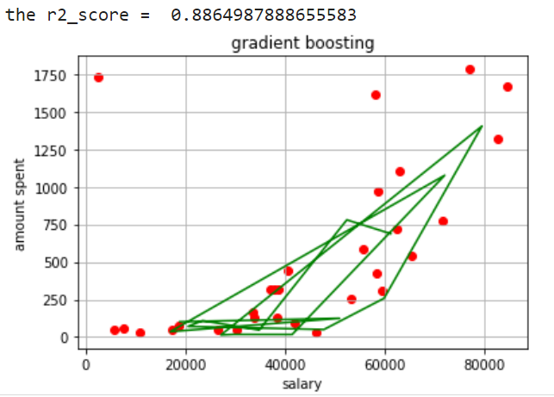

Figure 2: amount spent

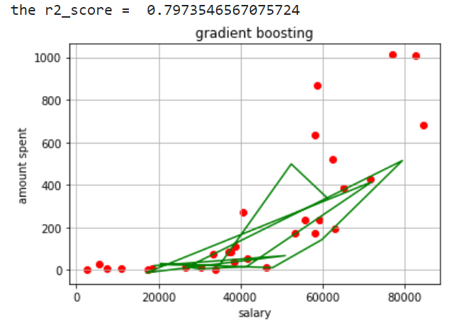

**Data**

Dataset contains 2,240 customers’ information salary, kind, education, birth, marital status, kids, amount spending on item, Numbers of purchases made and place of purchase,

Figure 3: dataset





# Result

I have a regression model with accuracy reach out of 83% to predict the total amount spent on products and regression model for amount spent on specific type of our products with accuracy reach out of 75%.

# Discussion

In my opinion, customer behavior and personality have a huge impact on market, producing products and the price of a products from what they like and need.

# Conclusions

The increase of the products day by day and ideas of nowadays products lead the way for marketing companies and employee approaches and technologies that are needed to predict who would like to pay for it. The work in this paper specifies an approach for customer personal analysis. To predict amount spending on product, we extract the relevant data from marketing

company.

The overall customer personality is calculated by using a model that is presented in this report. This work is explanatory in nature and the prototype evaluated is a preliminary prototype.

The model shows that prediction of customer personality is a non-trivial task for machine learning. A lot of preprocessing is needed just to be able to run an algorithm. The main problem for customer analysis is to craft the machine representation of human personality and behavior. A lot of additional features are needed to make algorithms work more accurate, as we know human personality and behavior differ from one to other, even if they have the same behavior they will act differently.

I think that a slight improvement in regression accuracy for the given training dataset could be developed, but since it included a little of customers personality and behavior, the difference will be probably in the order of a few percent.

The thing that could possibly enhance regression outcomes will add a lot of additional examples (increase training dataset) and add more human’s personalities and behaviors, because given 2,240 examples clearly do not include all customers' personalities and behaviors. To know, a lot of customers' personalities and behavioral information certainly are missed.

# References

|  |  |
| --- | --- |
| [1] | "kaggle," [Online]. Available: https://www.kaggle.com/imakash3011/customer-personality-analysis. |
| [2] | "my profile," [Online]. Available: https://github.com/yasseralbatyeh. |